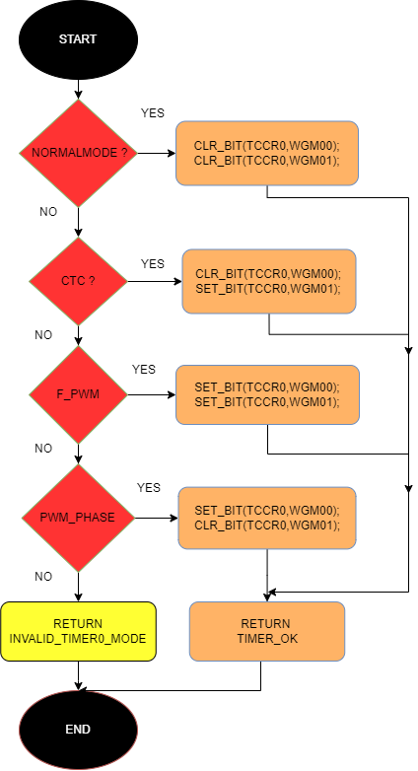

TIMER 0 INIT

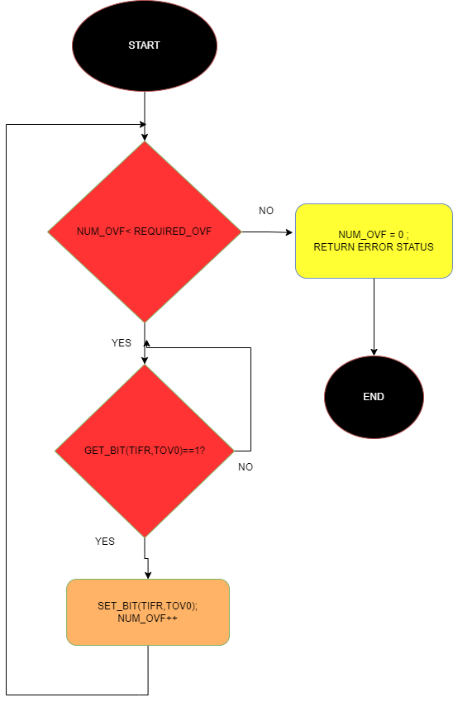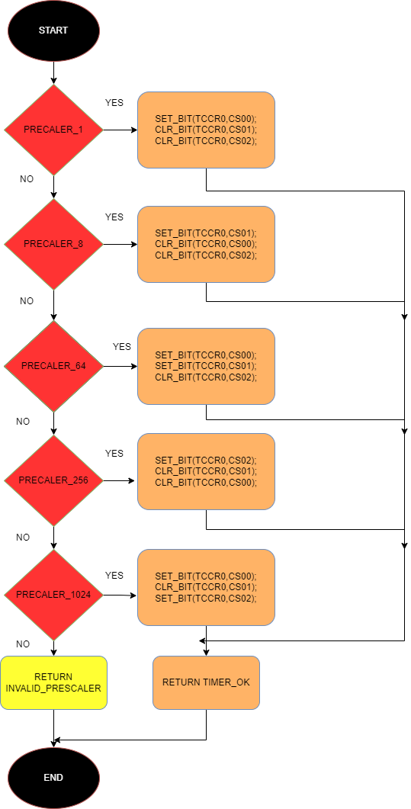

TIMER 0 SET OVERFLAG

TIMER 0 SET PRESCALER

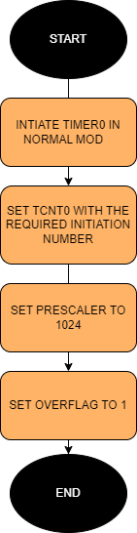

TIMER 0 PWM WITH NORMAL MODE

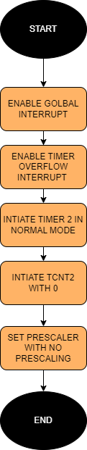

TIMER 2 WITH INTERRUPT

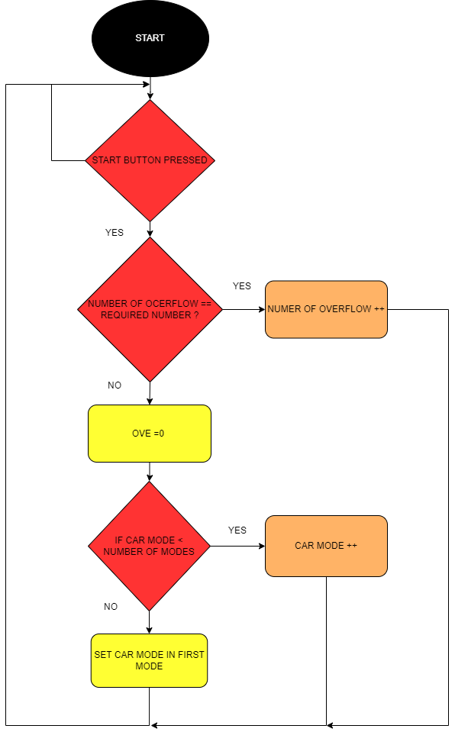

TIMER_2_ISR